CS303 Operating Systems

Lab: CPU Scheduling

Overview

- CPU scheduling: allowing one process to use the CPU while the execution of another process is on hold (in waiting state) on the basis of a particular strategy.
- The aim of CPU scheduling: making the system efficient, fast, and fair: making full use of CPU to deliver minimum response time for all programs.
- Components involved in CPU scheduling: CPU scheduler + Dispatcher
- CPU scheduler: selects one of the processes in the ready queue to be executed by the CPU.
- Dispatcher: gives control of the CPU to the process selected. This function involves: Switching context / Switching to user mode / Jumping to the proper location in the user program to restart that program from where it left last time. The dispatcher should be as fast as possible, given that it is invoked during every process switch. The time taken by the dispatcher to stop one process and start another process is known as the Dispatch Latency.
- Types of CPU Scheduling:
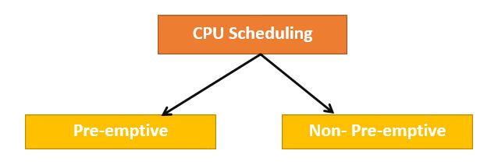
  - Preemptive Scheduling: tasks are mostly assigned with their priorities. Sometimes it is important to run a task with a higher priority before another lower priority task, even if the lower priority task is still running. The lower priority task holds for some time and resumes when the higher priority task finishes its execution.

  - Non-Preemptive Scheduling: the CPU has been allocated to a specific process. The process that keeps the CPU busy will release the CPU either by switching context or terminating.

- Important CPU scheduling Terminologies:
- Burst Time/Execution Time: It is a time required by the process to complete execution. It is also called running time.
- CPU/IO burst cycle: Characterizes process execution, which alternates between CPU and I/O activity.

- Arrival Time: when a process enters in a ready state.
- Finish Time: when process completes and exits from a system
- Multiprogramming: Several programs which can be present in memory at the same time.
- CPU scheduling Criteria:
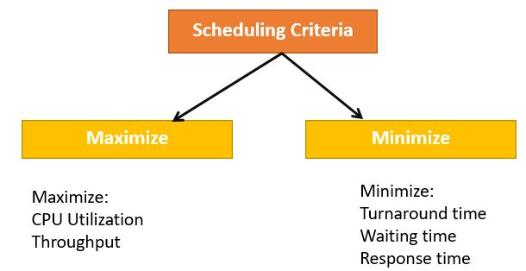

Maximize:
- CPU utilization: CPU utilization is the main task in which the operating system needs to make sure that CPU remains as busy as possible. It can range from 0 to 100%.
- Throughput: The number of processes that finish their execution per unit time is known Throughput.

Minimize:
- Waiting time: Waiting time is an amount of time that specific process needs to wait in the ready queue.
- Response time: It is an amount of time in which the request was submitted until the first response is produced.
- Turnaround Time: Turnaround time is an amount of time to execute a specific process. It is the calculation of the total time spent waiting to get into the memory, waiting in the queue and, executing on the CPU. The period between the time of process submission to the completion time is the turnaround time.

- Interval Timer: Timer interruption is a method that is closely related to preemption. When a certain process gets the CPU allocation, a timer may be set to a specified interval. Both timer interruption and preemption force a process to return the CPU before its CPU burst is complete. Most of the multi-programmed operating system uses some form of a timer to prevent a process from tying up the system forever.

- Purpose of Scheduling Algorithms:
  - The CPU uses scheduling to improve its efficiency.
  - It helps you to allocate resources among competing processes.
  - The maximum utilization of CPU can be obtained with multi-programming.
  - The processes which are to be executed are in ready queue.

- Types of Scheduling Algorithms:
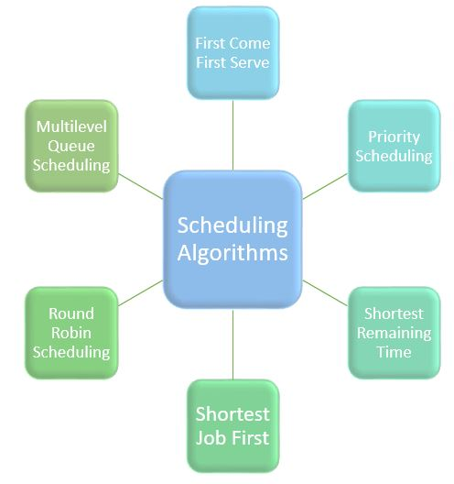
- First Come First Serve: FCFS

It is the easiest and most simple CPU scheduling algorithm. In this type of algorithm, the process which requests the CPU gets the CPU allocation first. This scheduling method can be managed with a FIFO queue (First In, First Out). As the process enters the ready queue, its PCB (Process Control Block) is linked with the tail of the queue. So, when CPU becomes free, it should be assigned to the process at the beginning of the queue.

Characteristics of FCFS method:
- It offers non-preemptive and pre-emptive scheduling algorithm.
- It is easy to implement and use.
- However, this method is poor in performance, and the general wait time is quite high.

- Shortest Job First: SJF

The process with the shortest execution time should be selected for execution next. This scheduling method can be preemptive or non-preemptive. It significantly reduces the average waiting time for other processes awaiting execution.

Characteristics of SJF Scheduling:
- It is associated with each job as a unit of time to complete.
- In this method, when the CPU is available, the next process or job with the shortest completion time will be executed first.
- This algorithm method is useful for batch-type processing, where waiting for jobs to complete is not critical.
- It improves job output by offering shorter jobs, which should be executed first, which mostly have a shorter turnaround time.

- Priority Based Scheduling

In this method, the scheduler selects the tasks to work as per the priority. Priority scheduling also helps OS to involve priority assignments. The processes with higher priority should be carried out first, whereas jobs with equal priorities are carried out on a round-robin or FCFS basis. Priority can be decided based on memory requirements, time requirements, etc.

- Round-Robin Scheduling

Round robin is the oldest, simplest scheduling algorithm. The name of this algorithm comes from the round-robin principle, where each person gets an equal share of something in turn. It is mostly used for scheduling algorithms in multitasking. This algorithm method helps for starvation free execution of processes.

Characteristics of Round-Robin Scheduling :
- Round robin is a hybrid model which is clock-driven
- Time slice should be minimum, which is assigned for a specific task to be processed. However, it may vary for different processes.
- It is a real time system which responds to the event within a specific time limit.

- Shortest Remaining Time: SRT

In this method, the process will be allocated to the task, which is closest to its completion. This method prevents a newer ready state process from holding the completion of an older process.

Characteristics of SRT scheduling method:
- This method is mostly applied in batch environments where short jobs are required to be given preference.
- This is not an ideal method to implement it in a shared system where the required CPU time is unknown.
- Associate with each process as the length of its next CPU burst. So that operating system uses these lengths, which helps to schedule the process with the shortest possible time.

- Multiple-Level Queues Scheduling

This algorithm separates the ready queue into various separate queues. In this method, processes are assigned to a queue based on a specific property of the process, like the process priority, size of the memory, etc. However, this is not an independent scheduling OS algorithm as it needs to use other types of algorithms in order to schedule the jobs.

Characteristic of Multiple-Level Queues Scheduling:
- Multiple queues should be maintained for processes with some characteristics.
- Every queue may have its separate scheduling algorithms.
- Priorities are given for each queue.

Exercise 1

Consider the processes in the table below:

- a) Draw a Gantt chart showing the order of execution of processes on the system in these 4 different scheduling algorithms: FCFS, SJF, SRT, and RR algorithm with the quantum of q = 2 seconds.
- b) Compute for each algorithm the average turnaround time.

NB: the processes switching time is not taken into consideration.

Process | P1 | P2 | P3 | P4 | P5
Arrival Time (in seconds) | 0 | 1 | 2 | 5 | 12
Burst Size (in seconds) | 6 | 6 | 2 | 4 | 8

FCFS (Avg Turnaround time = )
P1 (Turnaround time = )
Running
Ready
P2 (Turnaround time = )
Running
Ready
P3 (Turnaround time = )
Running
Ready
P4 (Turnaround time = )
Running
Ready
P5 (Turnaround time = )
Running
Ready

SJF (Avg Turnaround time = )
P1 (Turnaround time = )
Running
Ready
P2 (Turnaround time = )
Running
Ready
P3 (Turnaround time = )
Running
Ready

P4 (Turnaround time = )
Running
Ready
P5 (Turnaround time = )
Running
Ready

SRT (Avg Turnaround time = )
P1 (Turnaround time = )
Running
Ready
P2 (Turnaround time = )
Running
Ready
P3 (Turnaround time = )
Running
Ready
P4 (Turnaround time = )
Running
Ready
P5 (Turnaround time = )
Running
Ready

RR with q=2s (Avg Turnaround time = )
P1 (Turnaround time = )
Running
Ready
P2 (Turnaround time = )
Running
Ready
P3 (Turnaround time = )
Running
Ready
P4 (Turnaround time = )
Running
Ready
P5 (Turnaround time = )
Running
Ready

